

Project: Explore Weather Trends

**Done By:**

Abdullah Khalid Albisher

Data Analyst Nanodegree Program

April 2020

## **Outline**

This project is about analyzing and comparing local and global temperature. At first, the data was extracted and exported from a database in Udacity’s website using two SQL queries:

* **“select * from global_data”**

This query is used to get the global temperature average annually.

* **“select * from city_data where city='Riyadh' ”**

This query is used to get the local temperature average annually.

Since the extracted files contain long term averages, the data must be smoothen using the concept of moving averages. So, a moving average was calculated for both local and global temperature. The formula “AVERAGE” in Microsoft Excel is used to calculate a moving average with a certain period. Moving average period in this project was 10 years. So, for example, the average temperature for the year 1857 is the average from 1848-1857. Then the same formula was reflected on all the following years.

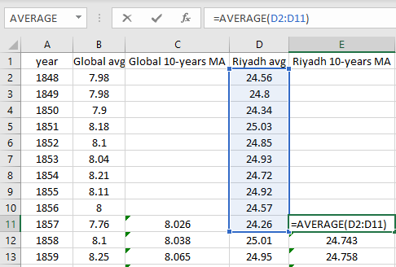

Finally, the following line chart was created in Excel to show the comparison of local and global temperature.

## **Observations**

1. Local temperature is higher than global temperature.
2. Both local and global temperature have the same curve.
3. The curve of both local and global temperature is increasing over the years.
4. The gap between global and local temperature is about 15 degree.